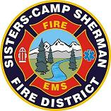
AGENDA
Notice of the Special Meeting with Executive Session of the
Board of Directors of the Sisters-Camp Sherman Rural Fire Protection District
September 2, 2026 8:30 a.m.
Zoom Link: https://us06web.zoom.us/j/82162706832?pwd=GoQnrBbRRcTEadRglcm75ZuXg7REsJ.1

- Open the Special Meeting
- Adjourn to Executive Session pursuant to ORS 192.660(2)(i) for the express purpose of reviewing and evaluating the performance of the Fire Chief.
- Resume special meeting
- Other business
- Adjourn meeting

